发文机关  Promulgator | ：  : | 全国人民代表大会常务委员会  The Standing Committee of the National People's Congress
发布日期  Date of Issue | ：  : | 2017.09.01  2017.09.01
生效日期  Effective Date | ：  : | 2017.10.01  2017.10.01
时效性  Effectiveness | ：  : | 现行有效  Current
文号  No. | ：  : | 主席令第七十五号  Presidential Decree No. 75

中华人民共和国国歌法

National Anthem Law of the People's Republic of China
中华人民共和国国歌法
National Anthem Law of the People's Republic of China
主席令第七十五号
Presidential Decree No. 75
《中华人民共和国国歌法》已由中华人民共和国第十二届全国人民代表大会常务委员会第二十九次会议于2017年9月1日通过，现予公布，自2017年10月1日起施行。
The National Anthem Law of the People's Republic of China, adopted at the 29th Session of the Standing Committee of the 12th National People's Congress of the People's Republic of China on 1 September 2017, is hereby promulgated, effective on 1 October 2017.
中华人民共和国主席 习近平
President Xi Jinping
2017年9月1日
September 1, 2017
中华人民共和国国歌法
National Anthem Law of the People's Republic of China
（2017年9月1日第十二届全国人民代表大会常务委员会第二十九次会议通过）
(Adopted at the 29th Session of the Standing Committee of the 12th National People's Congress on September 1, 2017)
第一条 为了维护国歌的尊严，规范国歌的奏唱、播放和使用，增强公民的国家观念，弘扬爱国主义精神，培育和践行社会主义核心价值观，根据宪法，制定本法。
Article 1 This Law is formulated in accordance with the Constitution in order to maintain the dignity of the national anthem, regulate the singing, playing and use of the national anthem, enhance the citizens' concept of nation, promote the spirit of patriotism, and cultivate and practice socialist core values.
第二条 中华人民共和国国歌是《义勇军进行曲》。
Article 2 The national anthem of the People's Republic of China is "March of the Volunteers".
第三条 中华人民共和国国歌是中华人民共和国的象征和标志。
Article 3 The national anthem of the People's Republic of China is a symbol and hallmark of the People's Republic of China.

一切公民和组织都应当尊重国歌，维护国歌的尊严。

All citizens and organizations shall respect the national anthem and maintain its dignity.
第四条 在下列场合，应当奏唱国歌：
Article 4 The national anthem shall be played on the following occasions:

（一）全国人民代表大会会议和地方各级人民代表大会会议的开幕、闭幕；

1. The opening and closing of sessions of the National People's Congress and of local people's congresses at various levels;
中国人民政治协商会议全国委员会会议和地方各级委员会会议的开幕、闭幕；
The opening and closing of meetings of the National Committee of the Chinese People's Political Consultative Conference and local committees at various levels;

（二）各政党、各人民团体的各级代表大会等；

2. All levels of congresses of political parties and people's organizations;

（三）宪法宣誓仪式；

(III) constitutional oath-taking ceremony;

（四）升国旗仪式；

(IV) The ceremony of hoisting the national flag;

（五）各级机关举行或者组织的重大庆典、表彰、纪念仪式等；

(V) significant celebrations, commendations and commemorative ceremonies held or organized by organs at all levels;

（六）国家公祭仪式；

(VI) the national memorial ceremony;

（七）重大外交活动；

(VII) significant diplomatic activities;

（八）重大体育赛事；

(VIII) Major sports events; and

（九）其他应当奏唱国歌的场合。

(IX) Other occasions where the national anthem shall be played.
第五条 国家倡导公民和组织在适宜的场合奏唱国歌，表达爱国情感。
Article 5 The state encourages citizens and organizations to sing the national anthem in the appropriate occasions to express their patriotism.
第六条 奏唱国歌，应当按照本法附件所载国歌的歌词和曲谱，不得采取有损国歌尊严的奏唱形式。
Article 6 The national anthem shall be sung according to the lyrics and music stated on the Appendix hereto, and shall not take any degrading form.
第七条 奏唱国歌时，在场人员应当肃立，举止庄重，不得有不尊重国歌的行为。
Article 7 When the national anthem is played, all the persons present shall be solemn and act in a dignified manner, and shall not conduct any disrespectful activity.
第八条 国歌不得用于或者变相用于商标、商业广告，不得在私人丧事活动等不适宜的场合使用，不得作为公共场所的背景音乐等。
Article 8 The national anthem shall not be used or disguisedly used for any trademark or commercial advertisement, or used in inappropriate occasions such as private funerals, or taken as background music at public places.
第九条 外交活动中奏唱国歌的场合和礼仪，由外交部规定。
Article 9 The provisions on occasions and etiquette rules for singing the national anthem in diplomatic events shall be formulated by the Ministry of Foreign Affairs.

军队奏唱国歌的场合和礼仪，由中央军事委员会规定。

The provisions on occasions and etiquette rules for singing the national anthem in the army shall be formulated by the Central Military Commission.
第十条 在本法第四条规定的场合奏唱国歌，应当使用国歌标准演奏曲谱或者国歌官方录音版本。
Article 10 When singing the national anthem on an occasion specified in Article 4 hereof, the standard performance music of the national anthem or an official recorded version of the national anthem shall be used.

外交部及驻外外交机构应当向有关国家外交部门和有关国际组织提供国歌标准演奏曲谱和国歌官方录音版本，供外交活动中使用。

The Ministry of Foreign Affairs and diplomatic missions abroad shall provide relevant national diplomatic departments and relevant international organizations with the standard performance music and official recorded version of the national anthem for application on diplomatic occasions.

国务院体育行政部门应当向有关国际体育组织和赛会主办方提供国歌标准演奏曲谱和国歌官方录音版本，供国际体育赛会使用。

The sports administrative department of the State Council shall provide relevant international sports organizations and competition event organizers with the standard performance music and official recorded version of the national anthem for use in international sports events.

国歌标准演奏曲谱、国歌官方录音版本由国务院确定的部门组织审定、录制，并在中国人大网和中国政府网上发布。

The standard performance music and official recorded version of the national anthem shall be examined, approved and recorded by the department designated by the State Council, and be released on the websites of the National People's Congress and the Chinese Government.
第十一条 国歌纳入中小学教育。
Article 11 The national anthem shall be included in primary and secondary school education.

中小学应当将国歌作为爱国主义教育的重要内容，组织学生学唱国歌，教育学生了解国歌的历史和精神内涵、遵守国歌奏唱礼仪。

Primary and secondary schools should take the national anthem as an important part of patriotism education, organize students to sing the national anthem, and teach students to understand the history and spiritual connotation of the national anthem.
第十二条 新闻媒体应当积极开展对国歌的宣传，普及国歌奏唱礼仪知识。
Article 12 News media shall actively conduct publicity for the national anthem to popularize etiquette rules of the national anthem.
第十三条 国庆节、国际劳动节等重要的国家法定节日、纪念日，中央和省、自治区、直辖市的广播电台、电视台应当按照国务院广播电视主管部门规定的时点播放国歌。
Article 13 On National Day, International Labour Day and other important national statutory holidays and commemorative days, the radio stations and television stations of the Central Government and various provinces, autonomous regions and centrally-administered municipalities shall broadcast the national anthem at the time stipulated by the radio and television department of the State Council.
第十四条 县级以上各级人民政府及其有关部门在各自职责范围内，对国歌的奏唱、播放和使用进行监督管理。
Article 14 People's governments at or above the county level and their relevant departments shall, within the scope of their respective duties, supervise the singing, playing and use of the national anthem.
第十五条 在公共场合，故意篡改国歌歌词、曲谱，以歪曲、贬损方式奏唱国歌，或者以其他方式侮辱国歌的，由公安机关处以警告或者十五日以下拘留；构成犯罪的，依法追究刑事责任。
Article 15 Whoever deliberately tampers with the lyrics or music of the national anthem, plays/sings the national anthem in a distorted or disparaged way, or otherwise insults the national anthem in any other way will be given a warning or detained for not more than 15 days by the public security organ; if a crime is constituted, he will be held criminally liable.
第十六条 本法自2017年10月1日起施行。
Article 16 The Law shall come into force as of October 1, 2017.
附件1：中华人民共和国国歌（五线谱版）
Appendix 1: National Anthem of the People’s Republic of China (Five-line Edition)
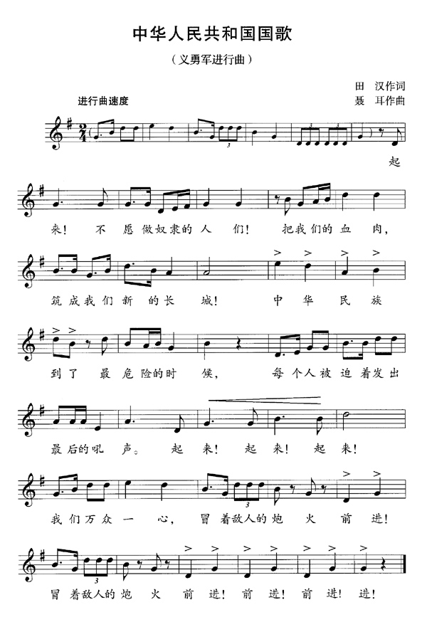
附件2：中华人民共和国国歌（简谱版）
Appendix 2: National Anthem of the People’s Republic of China (Simplified Spectrum)
